Whenever software is built, there is always scope for improvement and those improvements bring changes in picture. Changes may be required to modify or update any existing solution or to create a new solution for a problem. Requirements keep on changing on a daily basis so we need to keep on upgrading our systems based on the current requirements and needs to meet desired outputs. Changes should be analyzed before they are made to the existing system, recorded before they are implemented, reported to have details of before and after, and controlled in a manner that will improve quality and reduce error. This is where the need for System Configuration Management comes. System Configuration Management (SCM) is an arrangement of exercises that controls change by recognizing the items for change, setting up connections between those things, making/characterizing instruments for overseeing diverse variants, controlling the changes being executed in the current framework, inspecting and revealing/reporting on the changes made. It is essential to control the changes in light of the fact that if the changes are not checked legitimately then they may wind up undermining a well-run programming. In this way, SCM is a fundamental piece of all project management activities. Processes involved in SCM – Configuration management provides a disciplined environment for smooth control of work products. It involves the following activities:
- Identification and Establishment – Identifying the configuration items from products that compose baselines at given points in time (a baseline is a set of mutually consistent Configuration Items, which has been formally reviewed and agreed upon, and serves as the basis of further development). Establishing relationships among items, creating a mechanism to manage multiple levels of control and procedure for the change management system.
- Version control – Creating versions/specifications of the existing product to build new products with the help of the SCM system. A description of the version is given below: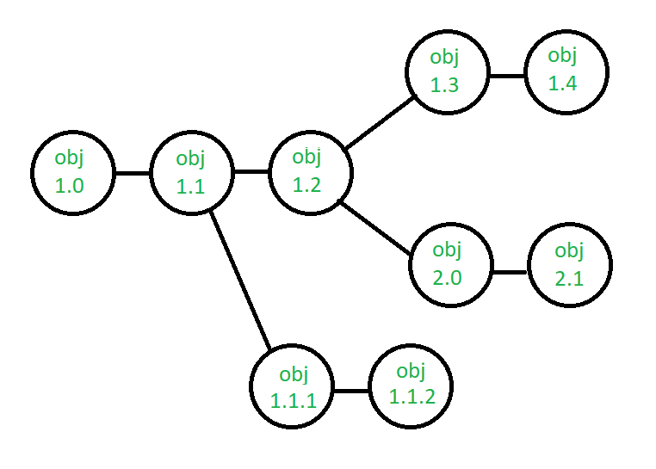Suppose after some changes, the version of configuration object changes from 1.0 to 1.1. Minor corrections and changes result in versions 1.1.1 and 1.1.2, which is followed by a major update that is object 1.2. The development of object 1.0 continues through 1.3 and 1.4, but finally, a noteworthy change to the object results in a new evolutionary path, version 2.0. Both versions are currently supported.
- Change control – Controlling changes to Configuration items (CI). The change control process is explained in Figure below: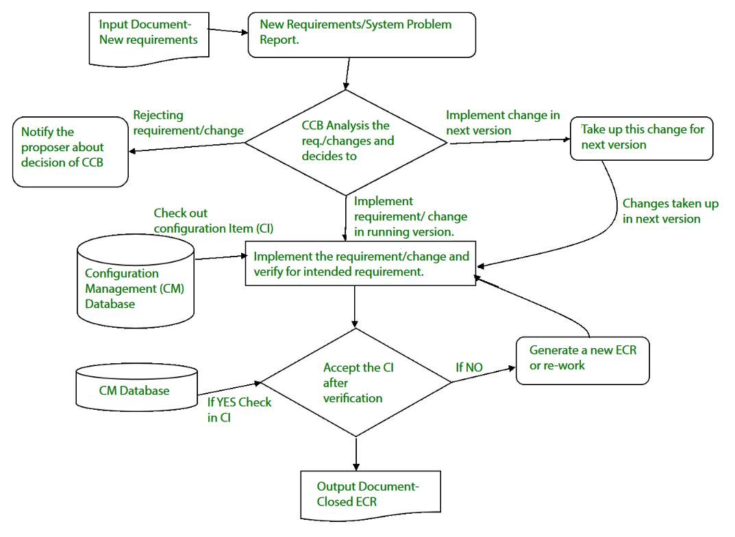A change request (CR) is submitted and evaluated to assess technical merit, potential side effects, overall impact on other configuration objects and system functions, and the projected cost of the change. The results of the evaluation are presented as a change report, which is used by a change control board (CCB) —a person or group who makes a final decision on the status and priority of the change. An engineering change Request (ECR) is generated for each approved change. Also CCB notifies the developer in case the change is rejected with proper reason. The ECR describes the change to be made, the constraints that must be respected, and the criteria for review and audit. The object to be changed is “checked out” of the project database, the change is made, and then the object is tested again. The object is then “checked in” to the database and appropriate version control mechanisms are used to create the next version of the software.
- Configuration auditing – A software configuration audit complements the formal technical review of the process and product. It focuses on the technical correctness of the configuration object that has been modified. The audit confirms the completeness, correctness and consistency of items in the SCM system and track action items from the audit to closure.
- Reporting – Providing accurate status and current configuration data to developers, tester, end users, customers and stakeholders through admin guides, user guides, FAQs, Release notes, Memos, Installation Guide, Configuration guide etc .
System Configuration Management (SCM) is a software engineering practice that focuses on managing the configuration of software systems and ensuring that software components are properly controlled, tracked, and stored. It is a critical aspect of software development, as it helps to ensure that changes made to a software system are properly coordinated and that the system is always in a known and stable state.
SCM involves a set of processes and tools that help to manage the different components of a software system, including source code, documentation, and other assets. It enables teams to track changes made to the software system, identify when and why changes were made, and manage the integration of these changes into the final product.

The key objectives of SCM are to:
- Control the evolution of software systems: SCM helps to ensure that changes to a software system are properly planned, tested, and integrated into the final product.
- Enable collaboration and coordination: SCM helps teams to collaborate and coordinate their work, ensuring that changes are properly integrated and that everyone is working from the same version of the software system.
- Provide version control: SCM provides version control for software systems, enabling teams to manage and track different versions of the system and to revert to earlier versions if necessary.
- Facilitate replication and distribution: SCM helps to ensure that software systems can be easily replicated and distributed to other environments, such as test, production, and customer sites.
- SCM is a critical component of software development, and effective SCM practices can help to improve the quality and reliability of software systems, as well as increase efficiency and reduce the risk of errors.

The main advantages of SCM are:
- Improved productivity and efficiency by reducing the time and effort required to manage software changes.
- Reduced risk of errors and defects by ensuring that all changes are properly tested and validated.
- Increased collaboration and communication among team members by providing a central repository for software artifacts.
- Improved quality and stability of software systems by ensuring that all changes are properly controlled and managed.

The main disadvantages of SCM are:
- Increased complexity and overhead, particularly in large software systems.
- Difficulty in managing dependencies and ensuring that all changes are properly integrated.
- Potential for conflicts and delays, particularly in large development teams with multiple contributors.
Identification of Objects in the Software Configuration
To manage and control software configuration items each must be different named and then build using an object-oriented approach. 2 kinds of objects can be identified [CHO89] that are aggregate objects and basic objects. A basic objects air a unit of text which has been develop through a software engineer during design, analysis, coding of testing. Example for a basic object might be a section of a needs specification a source listing for a module or a suite of test cases which are used to exercise the code. Aggregate object is a collection of other aggregate objects and basic objects. The Figure 11.3 is defining design specification which is an aggregate object. By the concept it can be viewed as a named list of pointers which specify basic objects like as module N and data model.
Every object has a group of distinct features which identify it uniquely like a description a name a list of resources and a realization. The object name is a character string which identifies the object unambiguously and the object description is a list of data items which identify:
- The SCI type example for document, program, data which is represented through the object;
- A project identifier, change and /or edition information.
The Resources are entities which are processed, provided, referenced or otherwise needed through the object [CHO 89]. Example for specific functions, data types or even variable names may be considered to be null and object for an aggregate object.
To configure object identification must also consider the relationships which exist among named objects. An object can be identified as a <part-of> describe a hierarchy of objects. Example for through using the simple notation which is given below.
E-R diagrams 1-4 <part-of> data model;
Data model <part-of> Design Specification;
We create a hierarchy of SCIs.
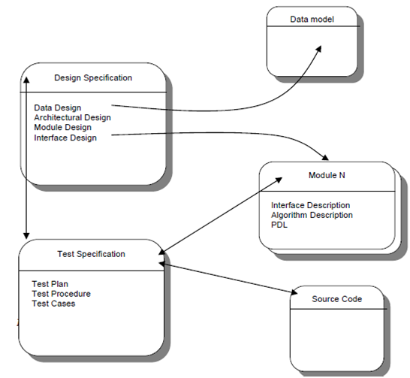
It is not realistic to suppose that the only relationship between objects in an object hierarchy is aligning striate paths of the hierarchical tree. In various other cases objects are interrelated across branches of the objects hierarchy. Example for data model is interrelated to data flow diagrams like supposing the use of structured analysis and also interrelated to a group of test cases for a specific equivalence class. These relationships cross-structural can be presented in the following manner:
Data model <interrelated> data flow model;
Data model <interrelated> test case class m;
In the 1st case the interrelationship is among a composite object although the 2nd relationship is among an aggregate object data basic object and model a test case class m.
The interrelationship among configuration objects can be presented with a module interconnection language MIL [NAR87]. MIL description interdependency between enables any version system and configuration objects to be automatically constructed. The scheme of identification for software objects must recognize in which objects evolve by the software procedure. Previously an object is baseline it is change various times and even further a baseline has been build modification may be quite frequent. It is possible to build an evolution graph [GUS89] any object. The evolution graph defines the modified history of the come and objects 1.1. Minor changes and corrections result in versions1.1.1 and 1.1.2 that is followed through a major update which is object1.2. The evolution or object1.0 continues by 1.3 and 1.4 but at the similar time a major changes to the object results in a new evolutionary path version 2.0 Both versions are presently supported.
It is quite possible that modification may be made to any version but not necessarily to all editions. How does the developer reference all modules like test cases and documents for version1.4? How does the marketing department know what customers presently have version 2.1? How can we be sure which changes to version2.1 source code are properly reflected in corresponding design documentation? A key feature in the answer to all of the above questions is identification.
A variety of automated SCM tools example for RCS, CCC, SCCS, and Aide-de-Camp have been created to aid in identification and other SCM tasks. Some cases a tool is designed to maintain full copies of only the most present edition. To achieve earlier versions of documents of programs changes catalogued through the tool are subtracted from the most recent version [TIC82]. Scheme makes the current configuration immediately available and other versions simply available.
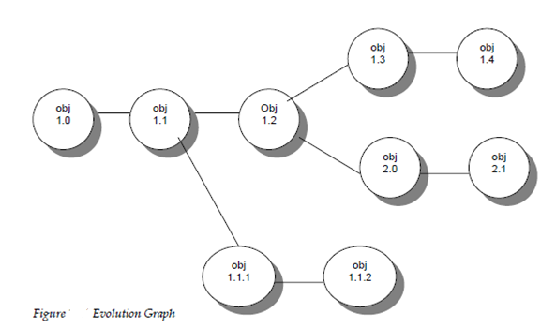
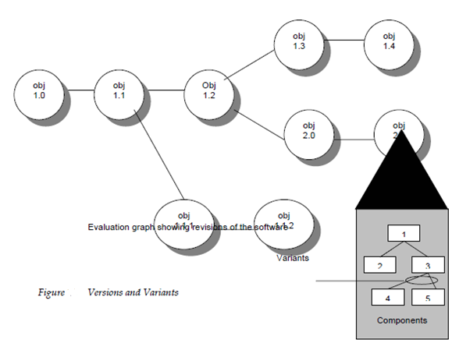
The process of controlling and documenting change for the development system is called Configuration Management. Configuration Management is part of the overall change management approach. It allows large teams to work together in s stable environment while still providing the flexibility required for creative work.
Here, we will discuss Configuration Management and Change Control and will cover objectives for both of them. Also, will focus on the process of change control, and later in this section, will discuss how we can revise the plan and what guidelines need to follow to make changes in the plan. Let’s discuss one by one.

Objectives of Configuration Management
Configuration management has three major purposes as follows.
- To identify the configuration of the product at various points in time.
- Systematically control changes to the configuration.
- Maintain the integrity and tractability of the configuration throughout the product life cycle.
When developing and maintaining a project, changes are inevitable. When the project starts, there are multiple changes to the parameters of one or more projects. The objective of the change control is to identify, evaluate, prioritize, and control changes to the project. The change is made to the project if there is any request by a project member or a stakeholder.

Different Roles for Change Control
The role of different persons and processes for change control will be as follows:
Role | Tasks
Interested Party | Documents the change requested, along with priority of the change, approaches to handle the change, work around if the change is not implemented.
Project Manager | Acknowledge the change applies to this project.
Change Control Board | Enter the change request into tracking system log.
Project Team Member | Review the change request and determine whether or not it is worth evaluating for action.
At the end, change has to be informed to requestor.

Process of Change Control
It is as shown in the following diagram as follows:
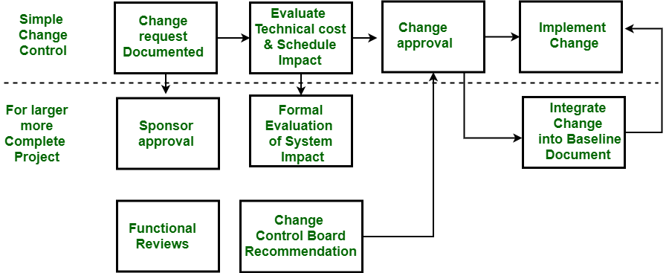
Change Control in Project Management

Revise the Plan
If there are significant changes in the project deliverables, schedule, budget or approach, the project plan s to identify. This is also done at the end of each major life cycle phase. The purpose is to revise the project plan is to accommodate significant changes, so that the documented plan reflects the plan in use by the project Team. This is the task of the senior manager to reviews the change to project plan and approve those changes.
The following guidelines should be followed while making changes as follows.
- No one is allowed to change anything in the project without knowing others.
- Every change must ensure quality.
- There should be a formal change control system on the basis of which the project s changed.
- The project should be flexible so that changes can be made easily.
- Records will be properly maintained after change and also revised plan should also be ready.
A project that will need to manage changes to the project scope or the product description and design should have a configuration management plan at the outlet.

